AI to improve the lifestyle:

Output Screenshots:

This is the front page of our project

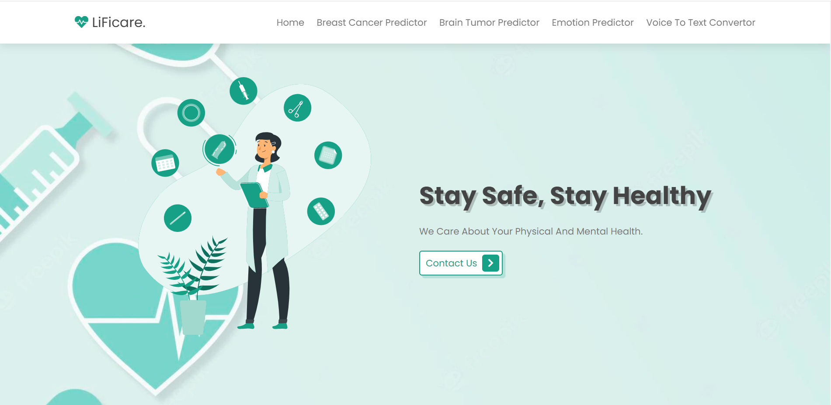
If you click breast cancer predictor button , then it will take you to the below page.This page contain some information about breast cancer . if you want to predict the cancer click the the predict button.

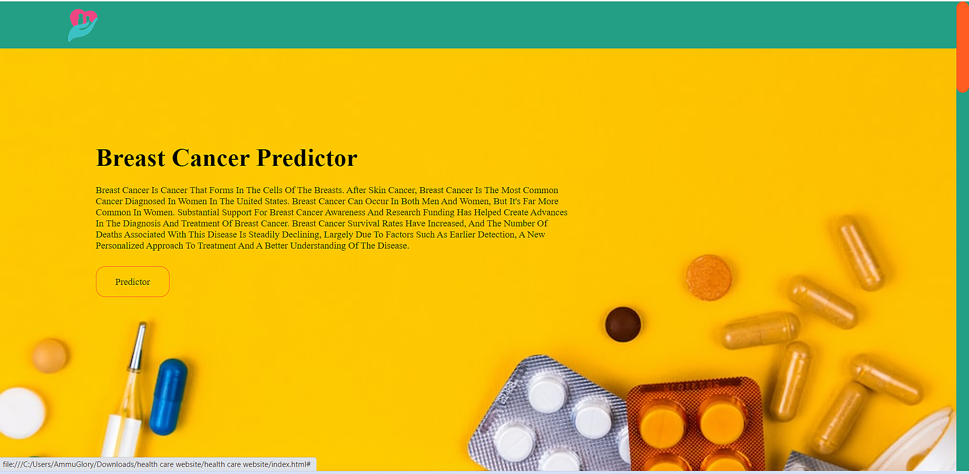
This is the predictor page. It is designed by Machine learning technology.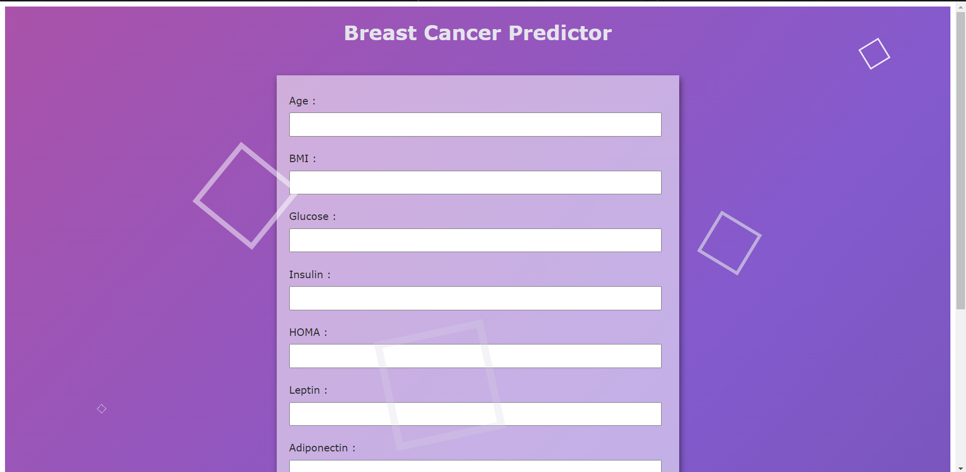

If you click the bran tumor predictor button, then it will take you to the below page.This page contain some information about brain tumor . if you want to predict the tumor click the the predict button.
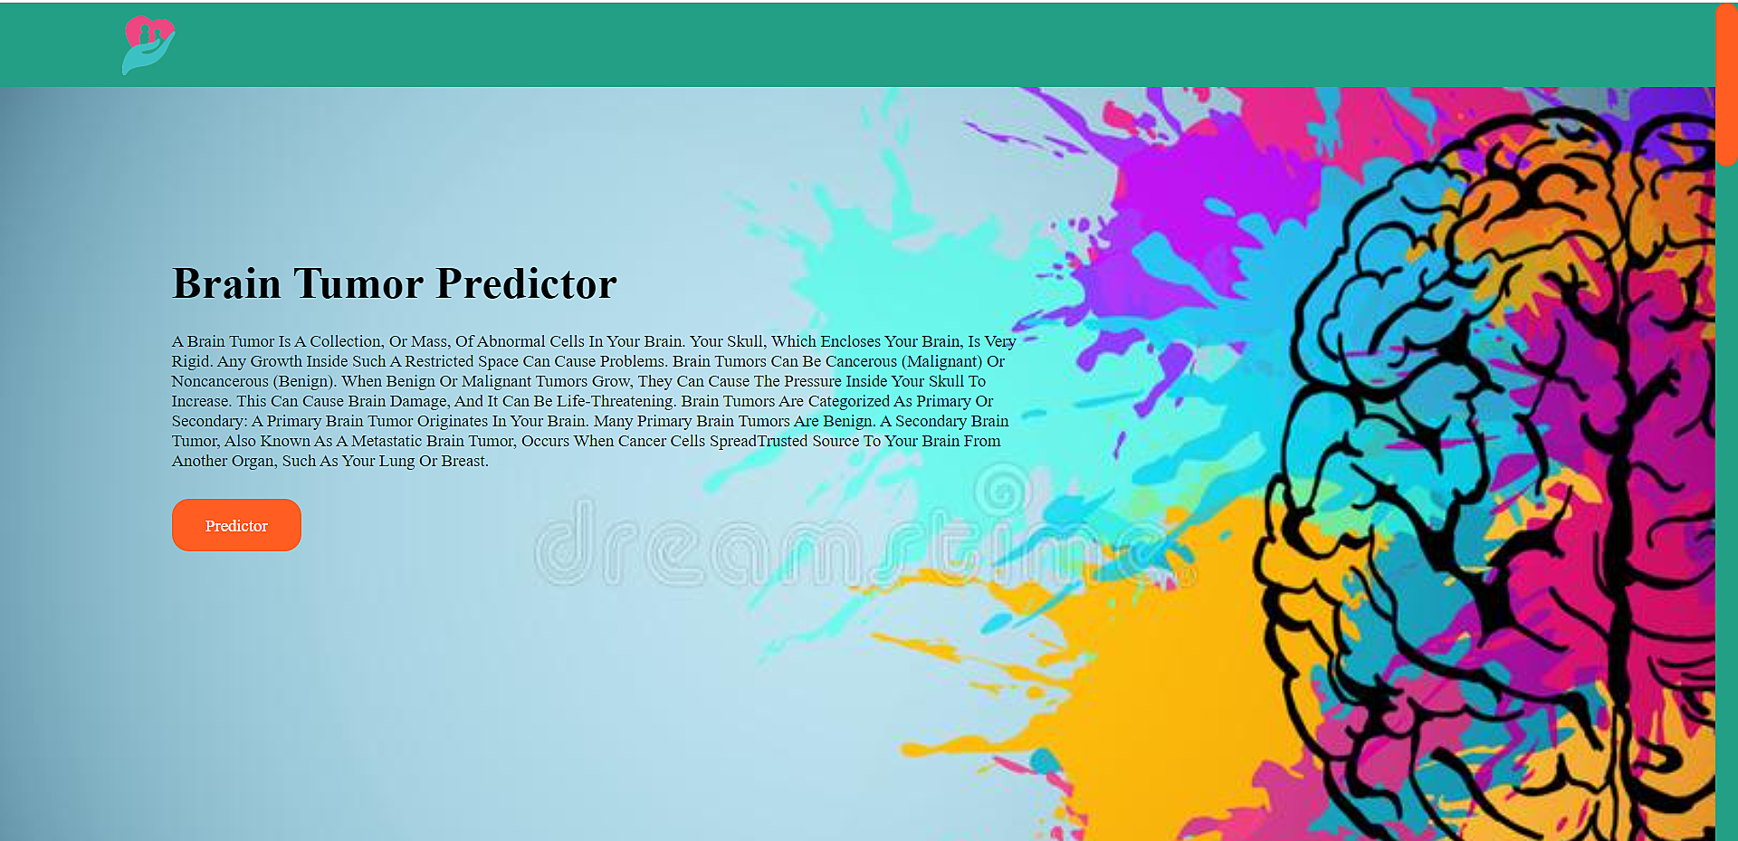

This is the predictor page. It is designed by Deep learning technology.

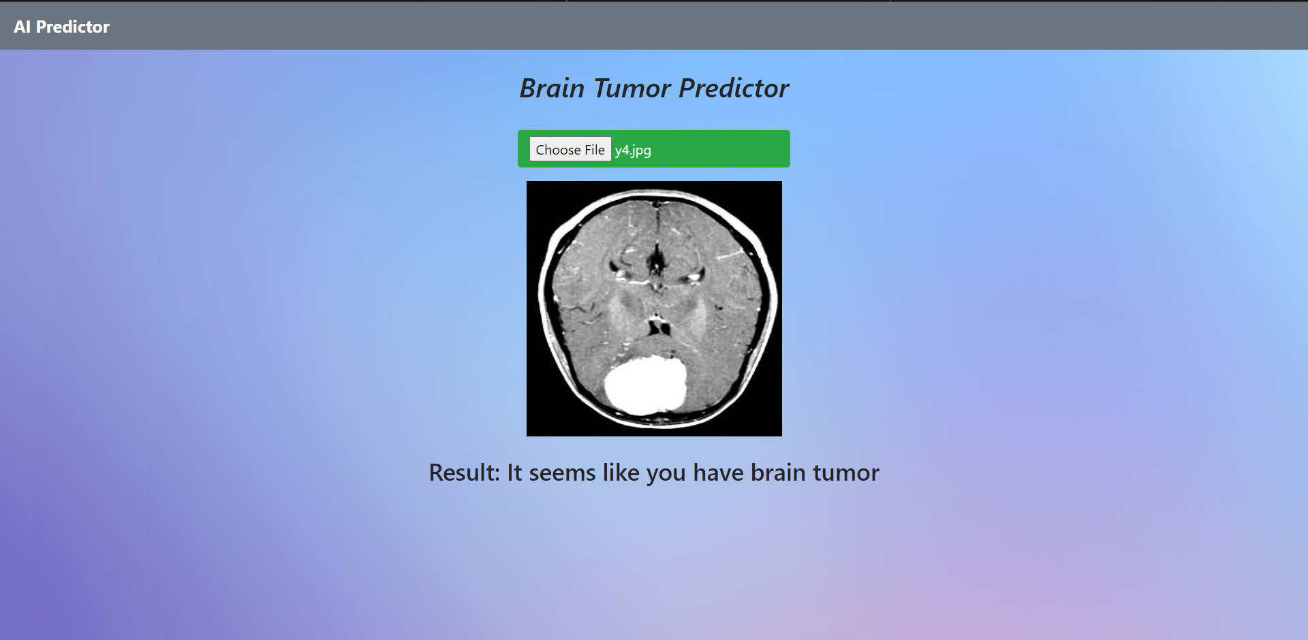

If you click Emotion predictor button, then it will take you to the below page.This page contain some information about emotion predictor . if you want to yor predict your emotions click the the predict button.
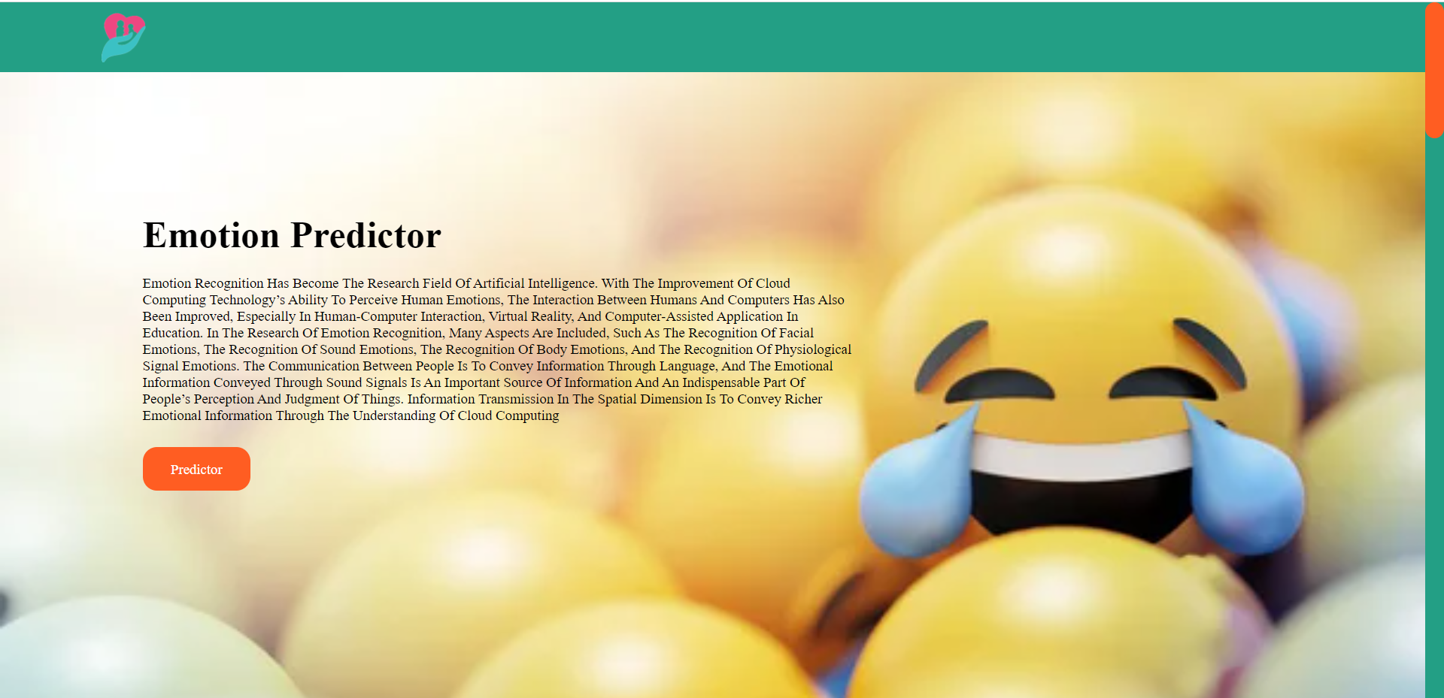
This is the predictor page. It is designed by Machine learning technology. Type the sentences in the blank box then click the submit button to predict the emotion level .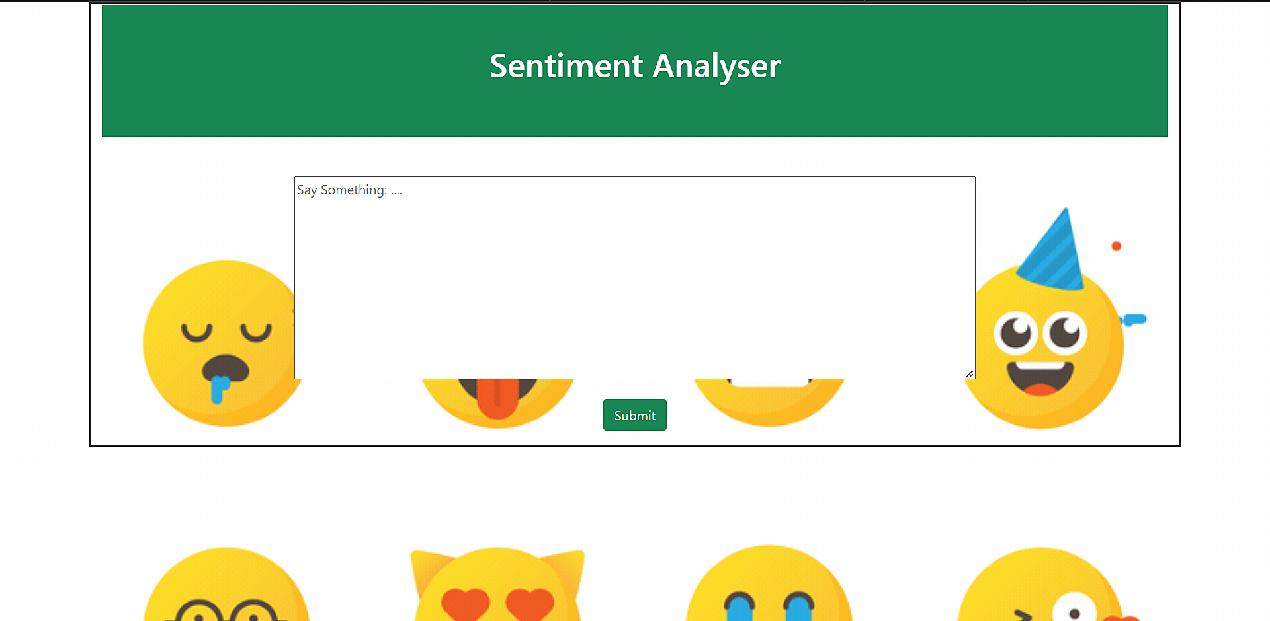

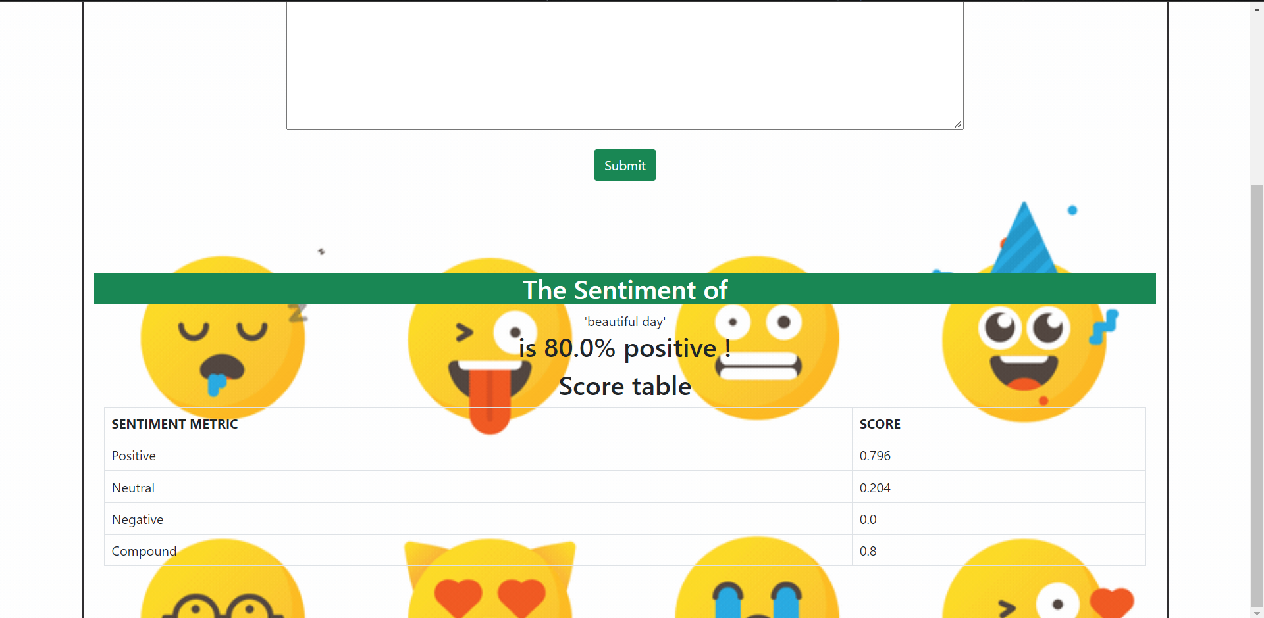

If you click Voice to text convertor button, then it will take you to the below page.This page contain some information about convertor . if you want to convert your voice to text click the convert button.

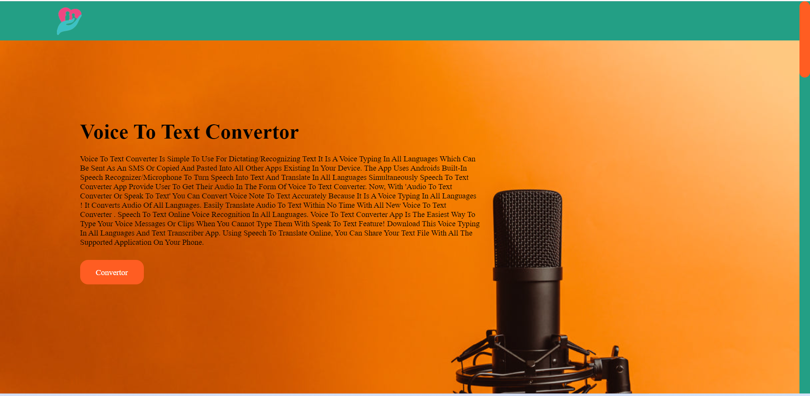

This is the voice to text convertor page. It is designed by Machine learning technology.upload the Audio files then click transcribe botton .

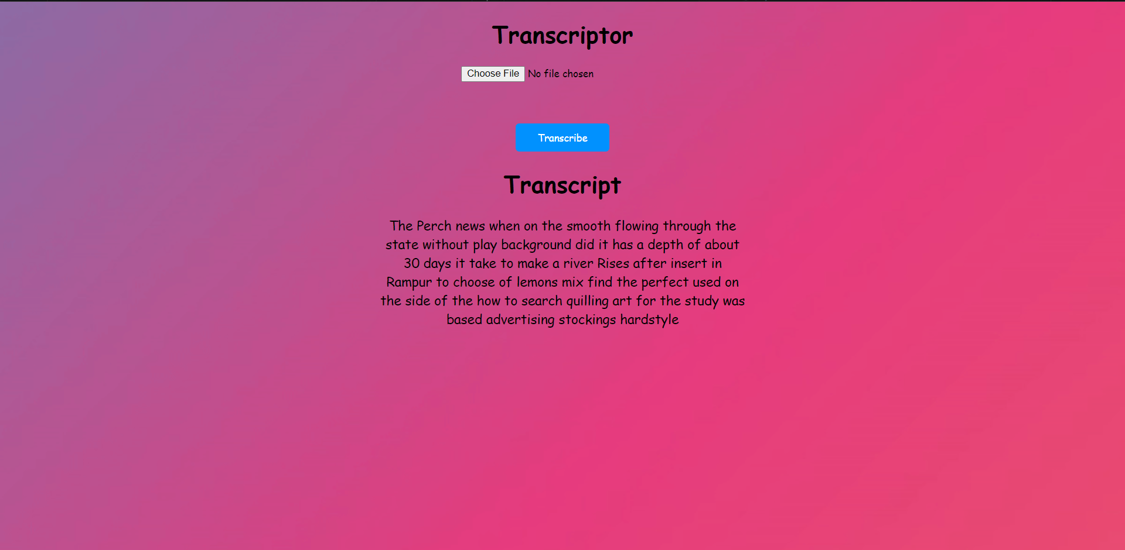

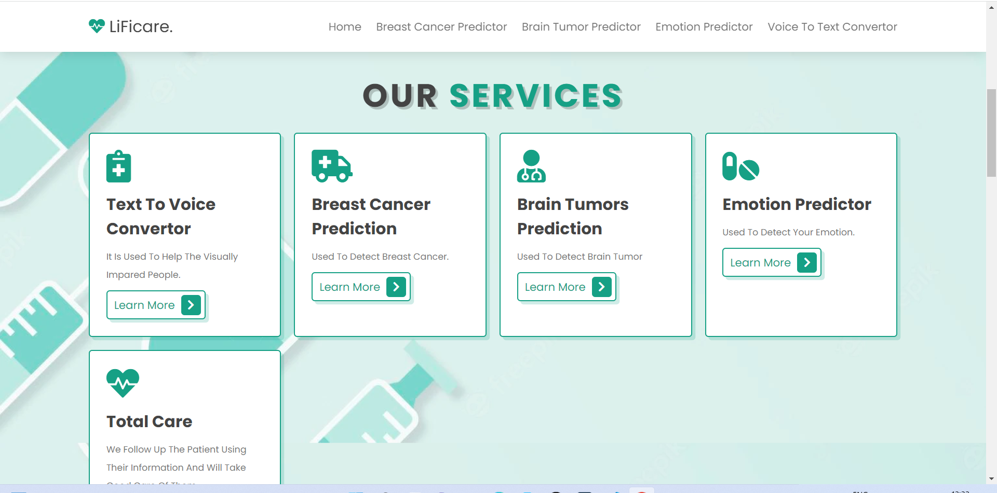
These are the final pages.



